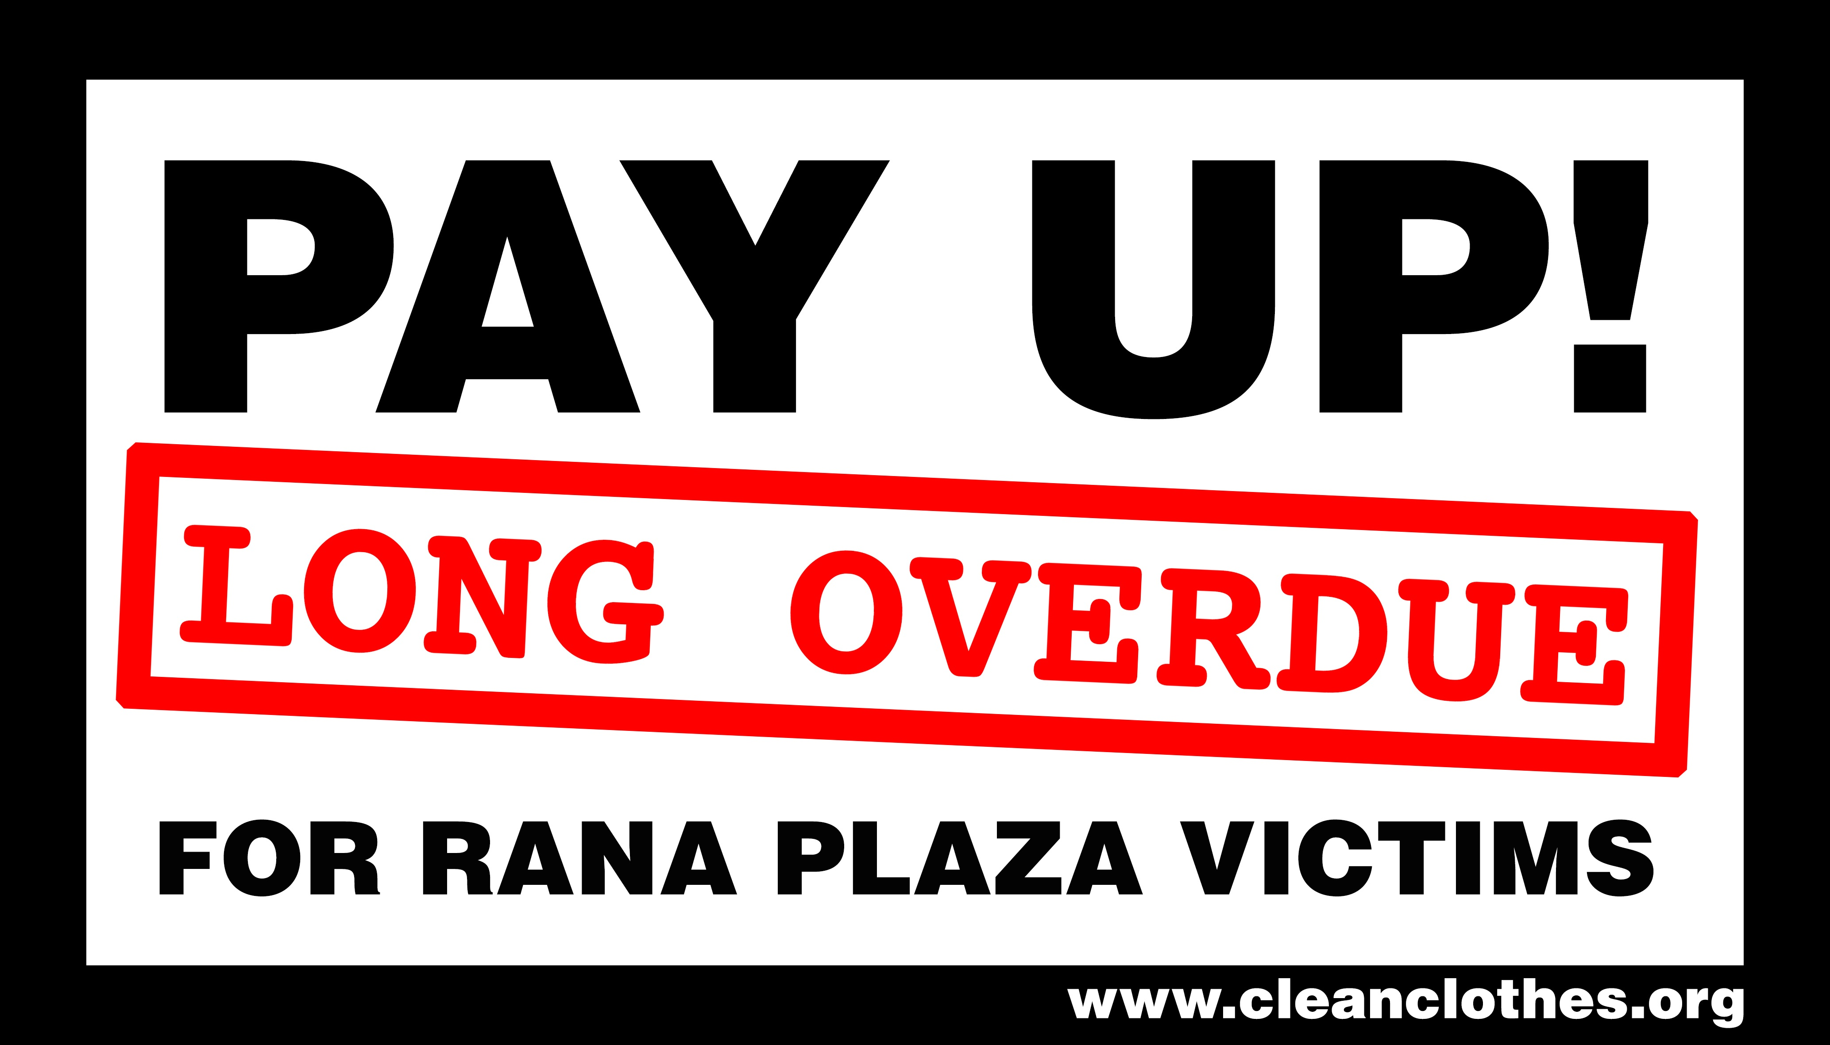

Dear [Benetton],

As the first anniversary of the appalling disaster at Rana Plaza approaches, I am contacting you to urge your company to pay compensation to the thousands of families that lost a loved one and workers who continue to suffer pain and injury as a result of the collapse.

On April 24th 2013, 1,138 people were killed and over 2,000 people injured, when the Rana Plaa building collapsed. Of course, nothing can be done to bring back those killed, or to reverse the psychological and physical scars that survivors will carry with them for the rest of their lives. However something CAN and SHOULD be done to alleviate the financial and health impacts on those left behind.

Since September 2013, the Rana Plaza Coordination Committee, chaired by the International Labour Organisaion and bringing together the Bangladeshi Government, the local and global garment industry, international and local trade unions and civil society, has been developing a scheme to ensure all the Rana Plaza victims, their families and dependents will receive payments to cover the losses they suffered as a result of the disaster.

The scheme is now ready and all those involved are confident that it will provide an credible, independent and transparent process for ensuring all those affected will finally get the compensation they deserve.

The Rana Plaza Donor Trust Fund, which will make the payments so desperately needed by the survivors of Rana Plaza is now open and waiting for donations.

A minimum of $40million is needed to enable all those affected to receive the support they need. It is vital that this money is donated prior to the 24th April. As the survivors approach this terrible anniversary we want to make sure that they can get through it knowing that they no longer have to suffer the financial hardship inflicted on them by this tragedy.

[Benetton] was one of the companies found to have a relationship with at least one of the factories that was housed in the Rana Plaza building. As such your company has a responsibility for ensuring those families affected receive the compensation they need to begin rebuilding their lives.

I am writing to you now to ask [Benetton] to make, without delay, a significant contribution to the Rana Plaza Fund and publicly declare that such a contribution has been made. I urge your company to appreciate that $40 million is needed to make this work and that therefore your donation should be sufficient to ensure that this total will be reached, reflect the size of your company and take into account the direct relationship your company had with at least one of the factories in the building.

For more information on the Trust Fund and how you can donate please see www.ranaplaza-arrangement.org.

I look forward to hearing soon that [Benetton] has taken positive action to support the Rana Plaza families and has taken its best efforts to make the 24th April 2014 not only a date for rememberance, but a date for new hope for the Rana Plaza families,

Yours Sincerely,

Name
Address / Email.

